Gesture Talk AI -Real-Time Sign Language Detection to Text and Voice Using OpenCV and Machine Learning
K S Shashikala Prajwal H N Omkar Maruti Nail
Sr. Asst. Professor Department of AIML Department of AIML
Department of AIML New Horizon College of New Horizon College of
New Horizon College of Engineering Bengaluru, India Engineering Bengaluru, India
Engineering Bengaluru, India prajwalh0909@gmail.com omkarnaik493@gmail.com
Ksshashikala2017@gmail.com
ORCID ID – 0009 0003 2644 1381

Santhosha
Department of AIML
New Horizon College of
Engineering Bengaluru, India
santhoshsanthosh60714@gmail.com

Abstract:
Gesture Talk AI bridges communication gaps for the hearing-impaired by translating real-time hand gestures into text and speech. Using OpenCV and Media Pipe for live hand tracking, and CNNs trained on sign language datasets, the system delivers instant, accurate gesture recognition. The output appears as readable text and is converted to speech via TTS engines like GTTS or pyttsx3. Lightweight, offline-capable, and scalable, this AI-powered solution enhances accessibility in education, healthcare, and public services.
Keywords:
Sign Language Recognition, Real-Time Gesture Detection, OpenCV, Media Pipe, Convolutional Neural Networks, Text-to-Speech, Accessibility, Assistive Technology.

I. INTRODUCTION
For millions of Deaf and Hard-of-Hearing (DHH) individuals worldwide, communication barriers significantly hinder effective engagement in
everyday interactions. Traditional solutions, such as sign language interpretation services, are often limited in availability, costly, and reliant on human interpreters. In today’s increasingly digital landscape, there is a pressing need for intelligent assistive technologies that offer real-time, accurate, and accessible communication support to bridge this gap [1].
Indian Sign Language (ISL) is one of the most widely used sign languages, consisting of distinct hand gestures that represent letters, words, and phrases. However, existing ISL recognition systems frequently struggle with real-time performance, accuracy, and robustness across diverse environments. To overcome these challenges, this study proposes a real-time ISL interpretation system that integrates deep learning techniques with advanced key point tracking. Specifically, it leverages for rapid hand gesture detection and Media Pipe for precise hand landmark extraction, there by enhancing both the efficiency and reliability of ISL recognition [2,3].

At the core of the system, a built-in webcam acts as a non-contact optical sensor capturing live visual data. This vision-based sensor converts incoming light into digital image frames, which serve as the primary input for gesture analysis. Media Pipe extracts 21 key points per hand from each frame, creating a skeletal representation of the hand’s posture, while detects and classifies specific ISL alphabet letters based on this visual information. The use of a standard webcam as the sensing device ensures continuous and reliable gesture data acquisition, enabling the recognition pipeline to operate in real time under varying lighting conditions and backgrounds using only commonly available hardware. This highlights

the system’s practical viability as an accessible and scalable assistive technology.
Beyond improving communication accessibility, AI-driven ISL recognition systems hold transformative potential across multiple sectors. In education, such systems can create more inclusive learning environments by facilitating seamless interaction between Deaf students, teachers, and peers. In healthcare, real-time ISL interpretation can bridge communication gaps between Deaf patients and medical professionals, thereby improving access to quality care [4]. Similarly, workplaces can benefit from integrating ISL recognition tools to foster inclusivity, enabling Deaf employees to fully participate in discussions and decision-making processes. The fusion of AI and deep learning in assistive technologies not only promotes inclusivity but also advances human–computer interaction, making communication more intuitive and accessible for individuals with hearing impairments [5,6].
II. Literature Review
The demand for intelligent, real-time sigxn language recognition systems has accelerated significantly from 2015 to 2025, driven by advances in computer vision, machine learning, and the growing emphasis on inclusive communication technologies for Deaf and Hard-of-Hearing (DHH) communities. This literature review examines recent developments in OpenCV-based implementations, machine learning approaches, and multimodal output systems that directly support the development of gesture recognition frameworks.
OpenCV has remained the cornerstone library for computer vision applications in sign language recognition, with researchers consistently demonstrating its effectiveness in real-time gesture detection and processing. The 2023 IEEE conference publication by researchers working on Python and OpenCV for Sign Language Recognition highlighted the critical role of computer vision in bridging communication gaps for hearing-impaired individuals [1]. Recent studies have emphasized OpenCV's capability in image capture and preprocessing, particularly when integrated with CNN techniques for machine training with text output. The advantage of OpenCV-based systems lies in their accessibility, as they eliminate the need for external sensors that are often cost-prohibitive for widespread adoption.
Template matching techniques using OpenCV have shown promise in sign language recognition systems, particularly for capturing hand gestures through camera-based interfaces. The IEEE 2020 publication on "Sign Language Recognition Using Template Matching Technique" demonstrated effective pattern recognition for visual sign patterns, extending applications to individuals with Autism Spectrum Disorder [4]. This approach has proven valuable for creating systems that can recognize specific gesture patterns without requiring extensive training datasets.
Machine learning algorithms, particularly CNNs, have shown significant promise in sign language recognition systems, with researchers addressing the complexity and large variation of hand movements through sophisticated classification models. The challenge of designing reliable features that accommodate wide gesture variations has been partially addressed through deep learning approaches [2]. K-Nearest Neighbor (KNN) algorithms have been explored but face major challenges including the curse of dimensionality, leading researchers to explore more sophisticated approaches.
Recent developments have incorporated LSTM and GRU feedback-based learning models for recognizing signs from isolated Indian Sign Language (ISL) video frames, demonstrating the effectiveness of sequential learning approaches. The MDPI 2022 publication "Deep sign: Sign Language Detection and Recognition Using Deep Learning" showcased four different sequential combinations for improved recognition accuracy [11]. Dynamic hand gesture recognition systems have evolved to handle temporal data sequences, with researchers developing Media Pipe, Inception-v3, and LSTM-based enhanced deep learning models to address multi-dimensional processing challenges [12].
Media Pipe has emerged as a powerful library for real-time hand tracking, with recent IEEE publications demonstrating its integration with CNN models for Indian Sign Language recognition and conversion to speech format. The 2023 IEEE conference paper highlighted Media Pipe’s capability in extracting pose details and generating text with enhanced recognition accuracy [5]. Multimodal gesture recognition systems have successfully combined Media Pipe with SICKITv5 for spatio-temporal feature fusion, while registerable hand gesture recognition approaches have incorporated Triple Loss learning to handle gesture diversity and variability [6].
SICKIT models have been specifically adapted for hand gesture recognition to assist hearing and speech-impaired individuals, with recent improvements in machine learning and object detection enabling real-time, image-based hand gesture identification. The IEEE 2022 publication demonstrated SICKIT's effectiveness in healthcare applications where sterilization requirements make touch-based interfaces impractical [10]. The integration of SICKIT and media Pipe for key point detection has shown impressive performance in complex pose recognition tasks, highlighting the potential for ensemble approaches in gesture recognition systems [7].
Recent developments have focused on creating comprehensive frameworks that not only recognize gestures but also convert them to speech format for various Indian regional languages, addressing the multilingual requirements of diverse user populations. Advanced computer vision techniques have enabled real-time sign language character detection using Media Pipe and Keras, significantly improving the responsiveness of communication interfaces. The 2025 publication in Towards Data Science demonstrated practical implementations for real-time character recognition [13].
Current systems face significant challenges due to the complexity and large variation of hand movements, making it difficult to design dependable features that accommodate wide variations in gestures. Environmental factors, lighting conditions, and individual signing styles continue to pose recognition challenges. The scarcity of comprehensive sign language datasets remains a significant barrier, with many existing technologies requiring extensive training data that may not be readily available for all sign language variants.
Recent research trends indicate a move toward ensemble approaches combining multiple detection and recognition frameworks, such as media Pipe with SICKIT variants, to achieve improved accuracy and robustness. Emerging research focuses on registerable hand gesture recognition systems that can learn and adapt to new gestures through clustering techniques, addressing the dynamic nature of sign language communication [8]. The gesture recognition improvement of media Pipe models based on historical trajectory assist tracking, Kalman filtering, and smooth filtering has shown promising results in enhancing recognition accuracy [9].
III. METHODOLOGY
Our proposed Indian Sign Language (ISL) recognition system follows a structured pipeline to interpret and classify hand gestures in real time. This methodology integrates advanced hand tracking, feature engineering, and deep learning-based classification to achieve high-accuracy gesture recognition.

A) Keras Framework Implementation: The system utilizes Keras as the primary deep learning framework due to its high-level neural network API capabilities and seamless integration with TensorFlow backend. Keras provides an intuitive interface for building, training, and deploying deep learning models while maintaining computational efficiency essential for real-time applications. The framework's modular design enables rapid prototyping and experimentation with different neural network architectures, making it particularly suitable for gesture recognition tasks that require iterative model refinement. The Keras implementation facilitates easy model serialization and loading, supporting the deployment requirements of the real-time sign language detection system.
Sequential Model Architecture: The core neural network architecture employs Keras Sequential model, which provides a linear stack of layers suitable for the gesture classification pipeline. The Sequential model architecture begins with input layers designed to process preprocessed hand landmark coordinates extracted from MediaPipe, followed by multiple dense layers with appropriate activation functions. The architecture incorporates dropout layers to prevent overfitting and batch normalization layers to accelerate training convergence. The final output layer utilizes softmax activation to produce probability distributions across different sign language gesture classes. This sequential approach ensures that data flows through the network in a straightforward manner, from input preprocessing to final gesture classification, making the model both interpretable and computationally efficient for real-time inference.
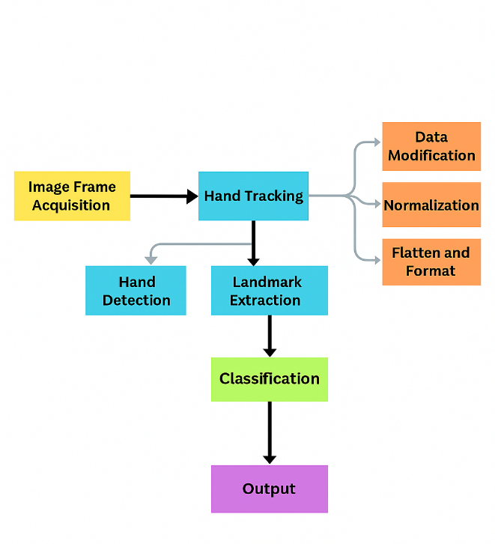
Figure 1.ISL Gesture Recognition Flowchart
A. Image Frame Acquisition
The system begins by capturing live video frames through a standard webcam or from a pre-recorded dataset. These frames showcase Indian Sign Language (ISL) hand gestures corresponding to both alphabet letters (A–Z) and numeric digits (1–9). The dataset used for training contains 26 alphabet classes and 9 numeric classes, each represented by over 1400 gesture samples. This extensive variety allows the model to effectively learn subtle variations and inter-class distinctions, enabling accurate recognition of both letters and numbers in real-time applications.
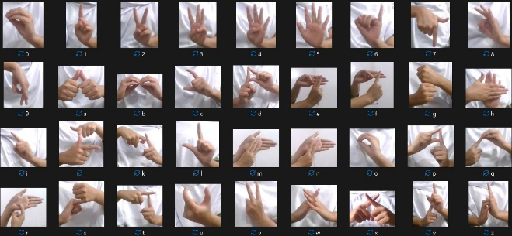
Figure 2. ISL Dataset used for model training
B. Hand Tracking with MediaPipe
Once frames are captured, the MediaPipe library is employed for real-time hand detection and tracking. It identifies 21 hand landmarks per frame, capturing the key joint positions. MediaPipe’s lightweight, accurate tracking pipeline enables robust gesture input extraction even under challenging lighting or background conditions.
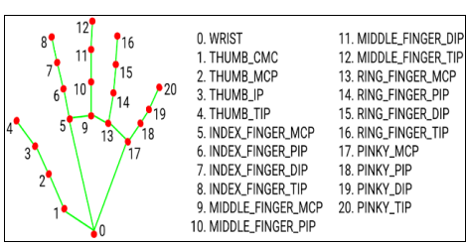
Figure3.Landmarks from Mediapipe Hand Tracking Module
C. Feature Extraction and Preprocessing
Each detected hand is converted into a vector of 21 (x, y) landmark coordinates:
Cantering: All coordinates are shifted relative to the hand’s centre to maintain spatial consistency.
Normalization: Landmarks are scaled based on the bounding box size to minimize hand size variation.
Flattening: The processed 2D coordinates are reshaped into a single 1D feature vector to feed into the classifier.

E. Output Gesture Generation
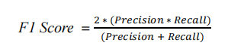
In the classification phase of our proposed architecture, the system aims to predict and return the corresponding Indian Sign Language (ISL) gesture as a value between 'A' to 'Z' or '1' to '9'. The recognized gesture is determined based on the input features processed through the trained neural network. After passing the feature vector through the network, the final layer generates a probability distribution across all possible gesture classes. Each class corresponds to a specific letter or numeric digit. The predicted gesture is identified by selecting the class with the highest probability score and mapping it to the appropriate symbol. This approach allows the model to support both alphabetical and numerical ISL gesture recognition efficiently.
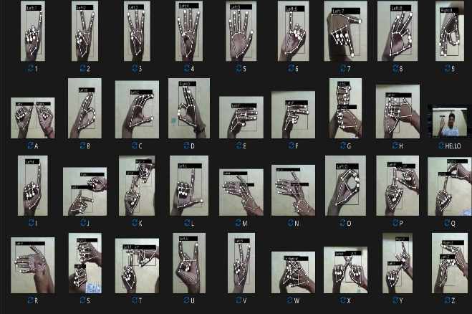
Figure 4. Output of working ISL-model
IV. RESULT ANALYSIS

